**Simple Install:**

* Menu -> "Language" -> "Define your language..."

This opens the "User Defined Language" dialog:

[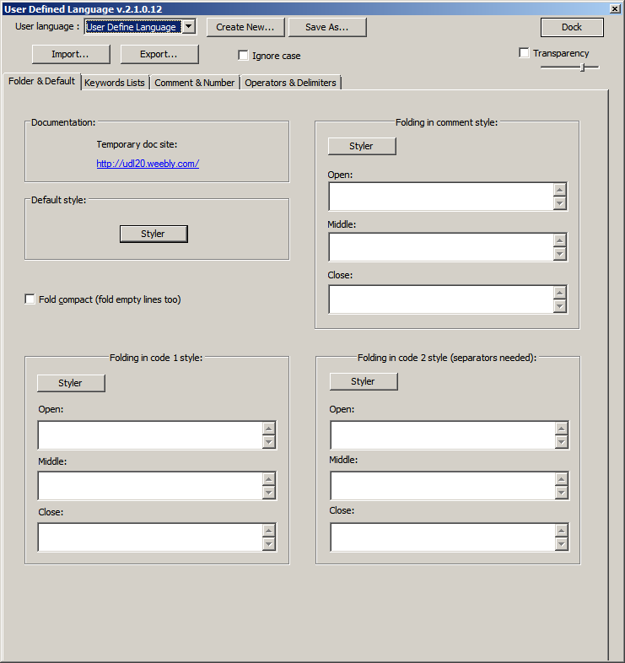](https://i.stack.imgur.com/2gaJ7.png)

* Click "Import" and navigate to the UDL file.
* Close and reopen the log file.